Lab Assignment #2
Cryptography

Steffen L. Norgren <ironix@trollop.org>
A00683006

COMP 7615 • BCIT • September 21, 2009

Table of Contents

Purpose 3
Procedures 3
Texts Used 3
Histogram for UnHistogram for Encrypted Text #1 4
Histogram for UnHistogram for Encrypted Text #2 5
Histogram for UnHistogram for Encrypted Text #3 6
Histogram for Encrypted Text #1 7
Histogram for Encrypted Text #2 8
Histogram for Encrypted Text #3 9
Discussion 10
Conclusion 10

Purpose
To create and analyse histograms of the character distribution in unencrypted and encrypted texts. Through such analysis of character frequency, one should be able to easily determine a method of decryption for texts that were encrypted using a simple cipher, such as the Caesar cipher.

Procedures

Texts Used
- Text #1 – Astounding Stories of Super-Science, February 1930:
http://www.gutenberg.org/ebooks/28617
- Text #2 – Astounding Stories of Super-Science, March 1930:
http://www.gutenberg.org/ebooks/29607
- Text #3 – Astounding Stories of Super-Science, April 1930:
http://www.gutenberg.org/ebooks/29390

Histogram for Unencrypted Text #1
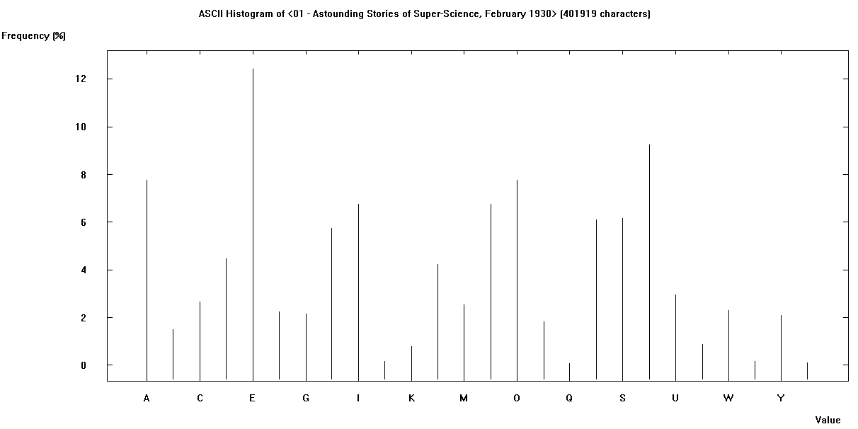

Histogram for Unencrypted Text #2
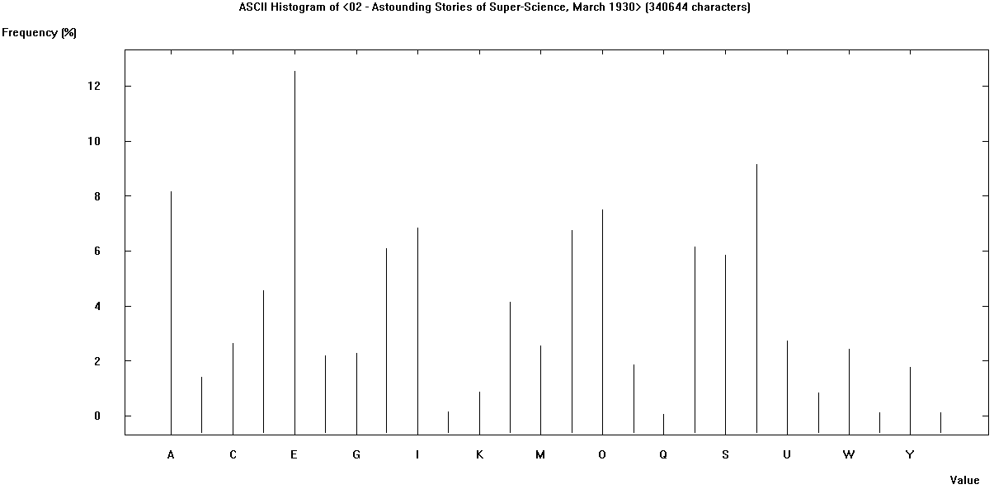

Histogram for Unencrypted Text #3
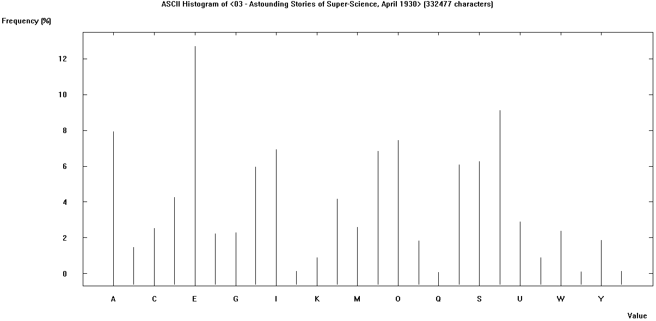

Histogram for Encrypted Text #1
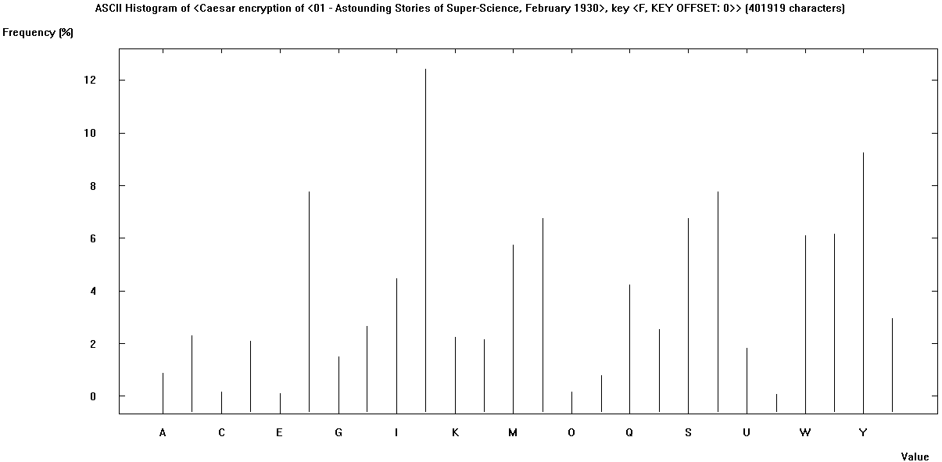

Histogram for Encrypted Text #2
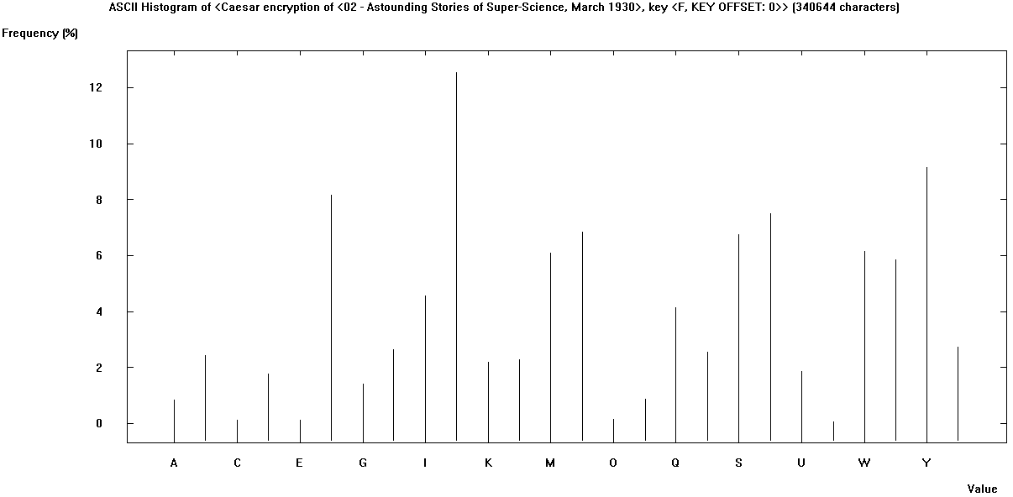

Histogram for Encrypted Text #3
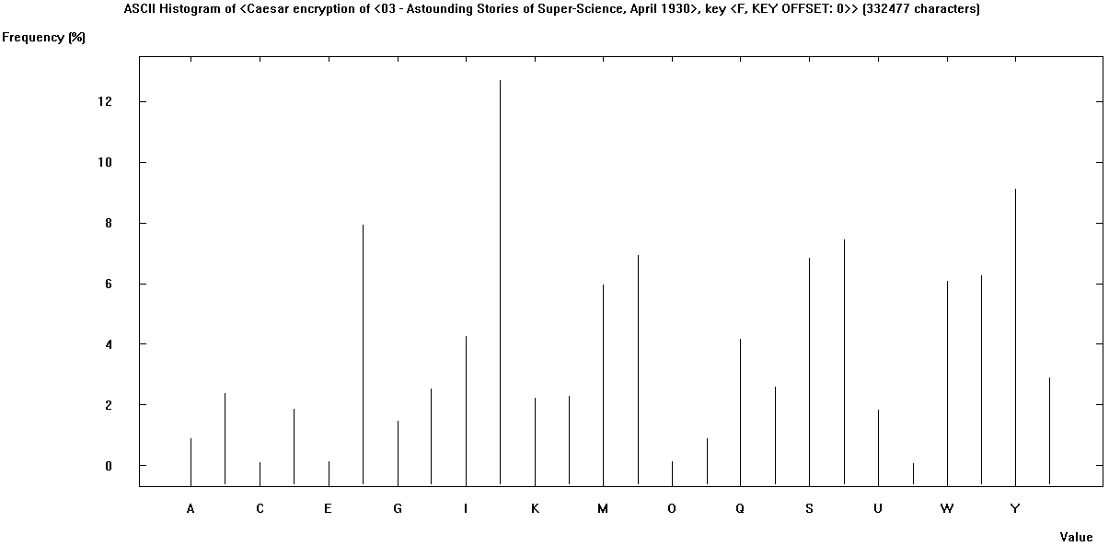

Discussion
Comparison of the unencrypted and encrypted character frequency histograms, one can easily make out patterns common to each text. The histograms for each unencrypted text are very similar with only a few minor variations, this is also true for the histograms of the encrypted texts. However, once you compare the histograms for an unencrypted and encrypted text, one can easily see that they are in fact the same histogram, only shifted to the left or right depending on what cipher key was used.

Conclusion
Through analysis of the unencrypted and encrypted histograms, one can easily discover the cipher used in each case by simply shifting the encrypted histogram over to the left or right until they both match.

